105 – 1750 West 75th Avenue, Vancouver, B.C., Canada V6P 6G2
Phone: 604.261.9450 Fax: 604.261.2256 www.setbc.org

TouchChat Dolch Words
Introduction
This vocabulary page is comprised of 27 Dolch basic sight words. By using the “hide icons” feature of TouchChat, the word list can be displayed without picture prompts, thus furthering children’s progress towards literacy.
Resource Type: Communication Board, TouchChat
Topics: Reading, literacy, TouchChat
Grades: K-2
Created by: Lorena Duran

Changing the Settings on TouchChat to Hide All Icons
1 | Choose Menu  Choose Settings | 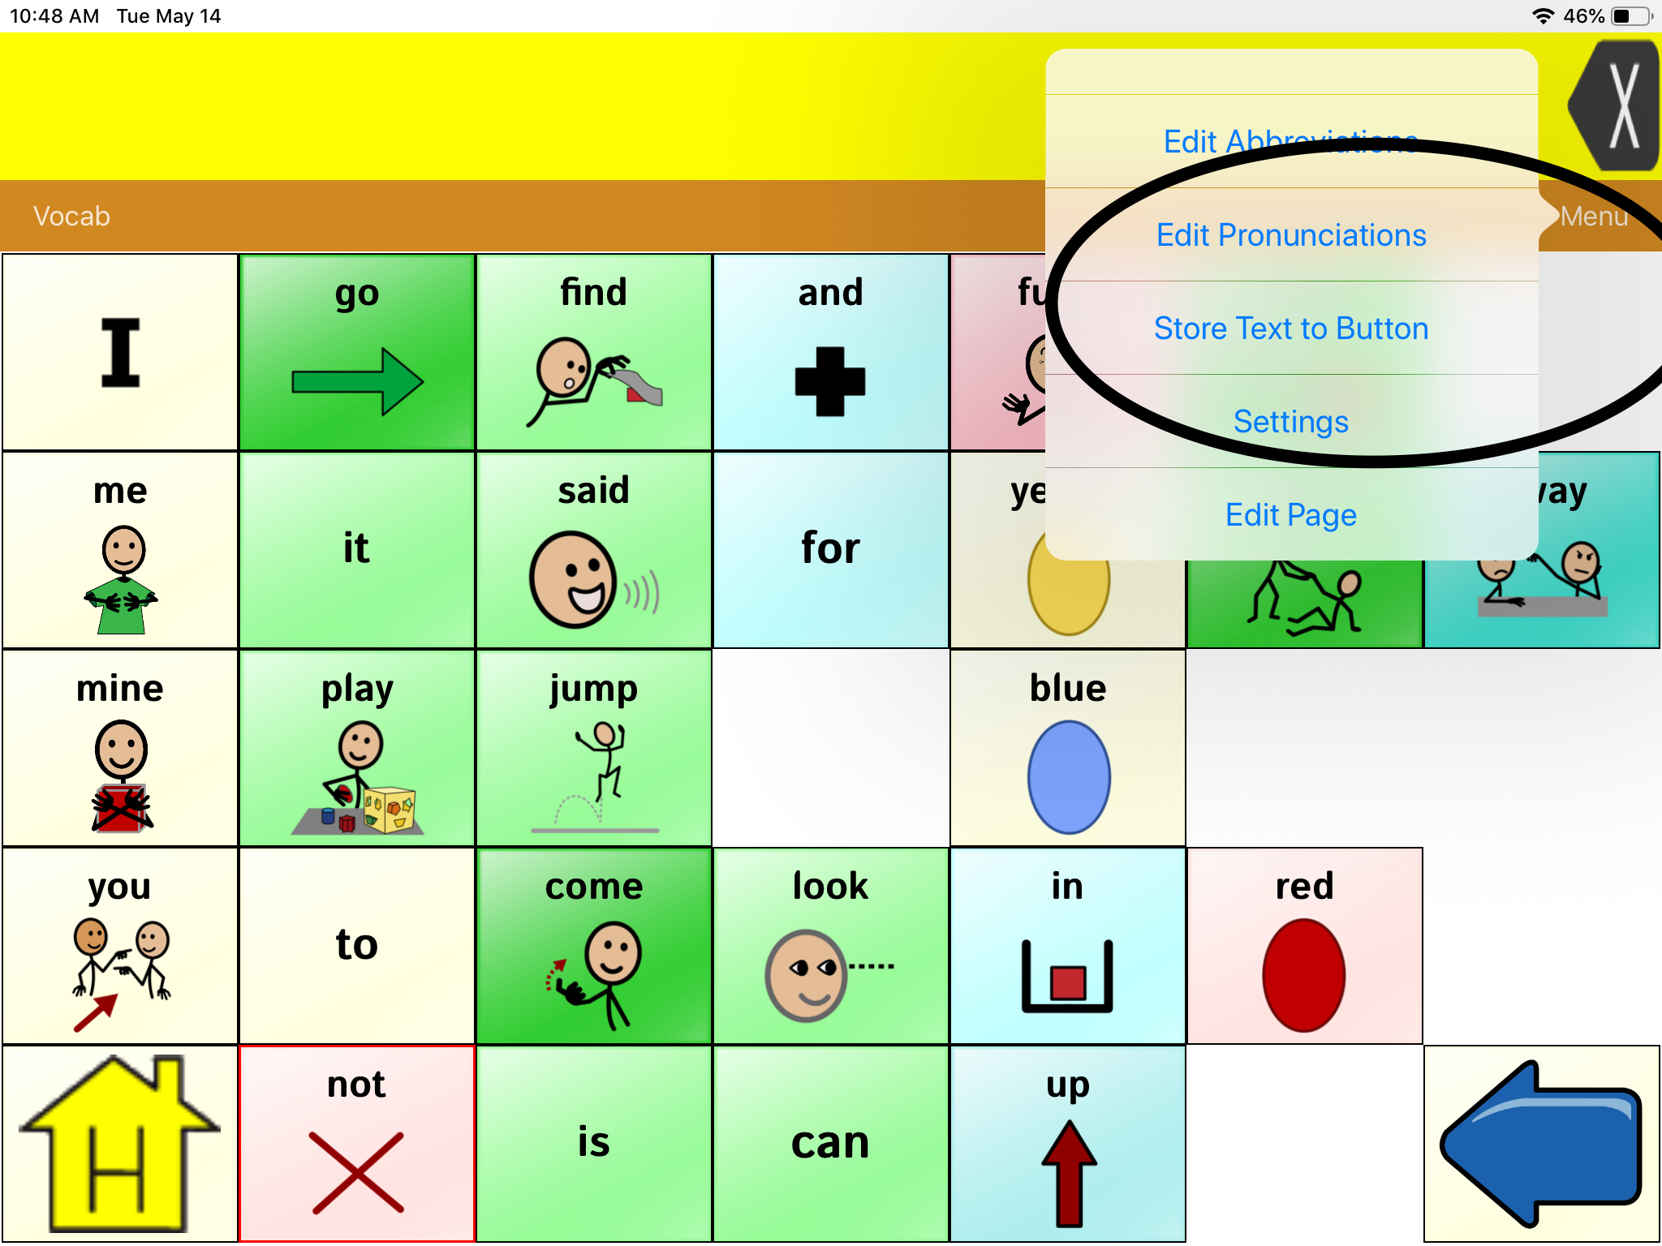
2 | Scroll down to Buttons category.  Find Hide all Icons and turn the green button to “on.”  Press “Done.” | 